**KNN (K Nearest Neighbours):**

The k-nearest neighbours (KNN) algorithm is a simple, easy-to-implement supervised machine learning algorithm that can be used to solve both classification and regression problems. The KNN algorithm assumes that similar things exist in close proximity. In other words, similar things are near to each other.

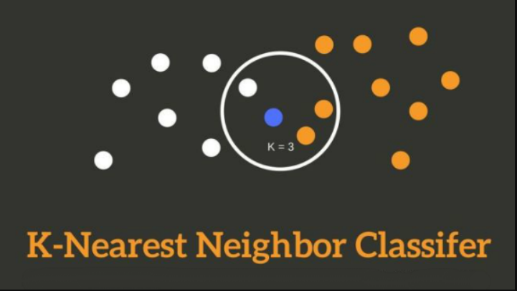

KNN works by finding the distances between a query and all the examples in the data,selecting the specified number examples(K) closest to the query, then votes for the most frequent label (in the case of classification) or averages the labels (in the case of regression).

**How Does The KNN Work?**

The K-NN working can be explained on the basis of the below algorithm:

* Step-1: Select the number K of the neighbors
* Step-2: Calculate the Euclidean distance of K number of neighbors
* Step-3: Take the K nearest neighbors as per the calculated Euclidean distance.
* Step-4: Among these k neighbors, count the number of the data points in each category.
* Step-5: Assign the new data points to that category for which the number of the neighbor is maximum.
* Step-6: Our model is ready.

**Example:**

* Firstly, we will choose the number of neighbors, so we will choose the k=5.
* Next, we will calculate the **Euclidean distance** between the data points. The Euclidean distance is the distance between two points, which we have already studied in geometry. It can be calculated as:

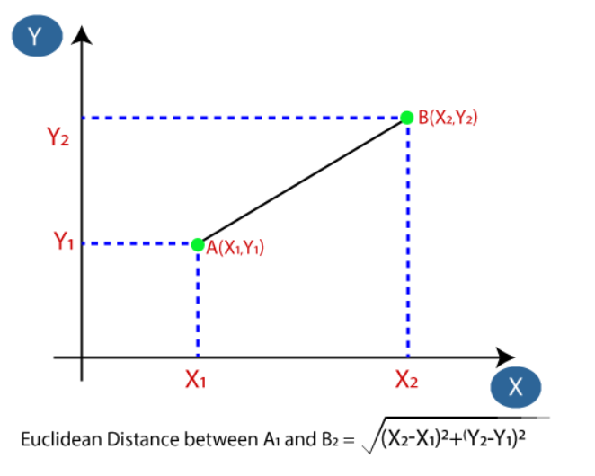

* By calculating the Euclidean distance we got the nearest neighbors, as three nearest neighbors in category A and two nearest neighbors in category B. Consider the below image:

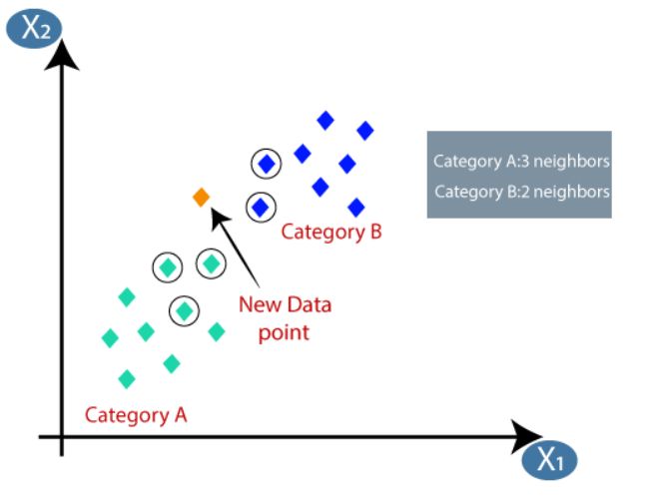

As we can see the 3 nearest neighbors are from category A, hence this new data point must belong to category A

**Note :**

* There is no particular way to determine the best value for "K", so we need to try some values to find the best out of them. The most preferred value for K is 5.
* A very low value for K such as K=1 or K=2, can be noisy and lead to the effects of outliers in the model.
* Large values for K are good, but it may have some difficulties.

**References:**

<https://towardsdatascience.com/machine-learning-basics-with-the-k-nearest-neighbors-algorithm-6a6e71d01761>

<https://www.javatpoint.com/k-nearest-neighbor-algorithm-for-machine-learning>

<https://www.youtube.com/watch?v=HVXime0nQeI>